Crop production in india

An Overview of Trends, Patterns, and

Future Projections

**PRAJWAL FULZELE**

Date – 20/07/2024

# INTODUCTION

Agriculture is the backbone of the Indian economy, providing employment to a significant portion of the population and contributing substantially to the country's GDP.

India's diverse climate and vast arable land make it one of the leading producers of various crops, including rice, wheat, pulses, and horticultural products.

This analysis aims to provide an in-depth understanding of crop production in India, examining historical trends, current patterns.

## DATA SOURCES

|  |  |
| --- | --- |
| * State Name * District Name * Crop Year | * Crop * Area * Production |

➢ Season

## METHODOLOGY

* **Data Cleaning**
* **Analyzing Data**

* **Critical Thinking**
* **Draw Insights**

## TOOLS

o Python o Excel o Power BI

**CROP PRODUCTION**

**DASHBOARD**

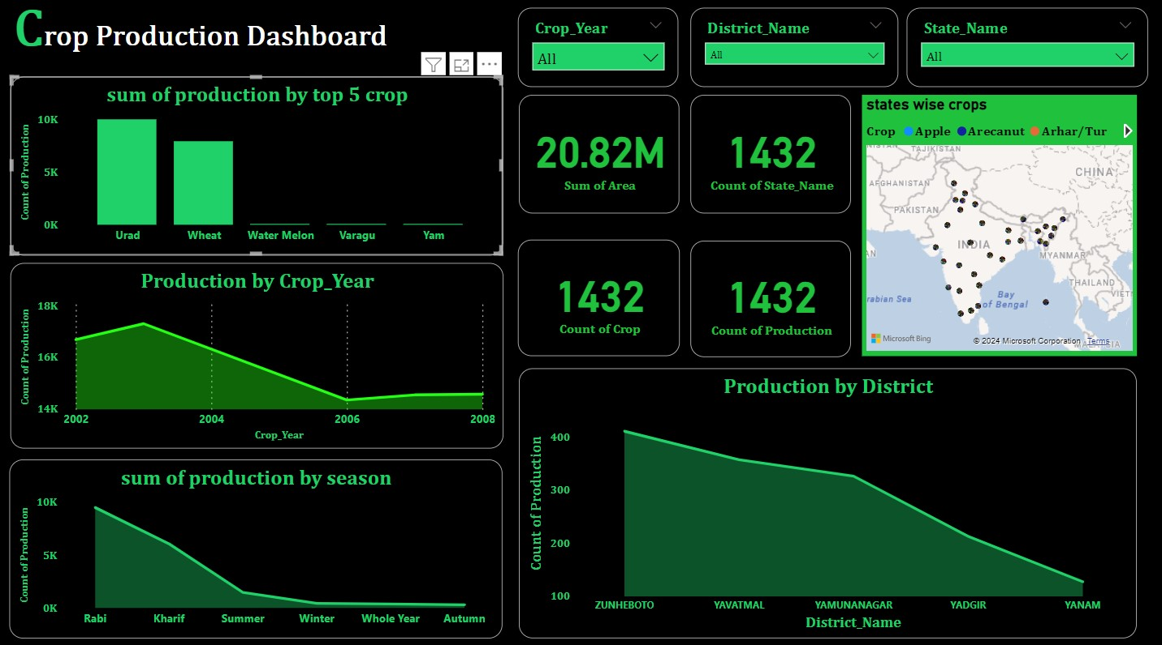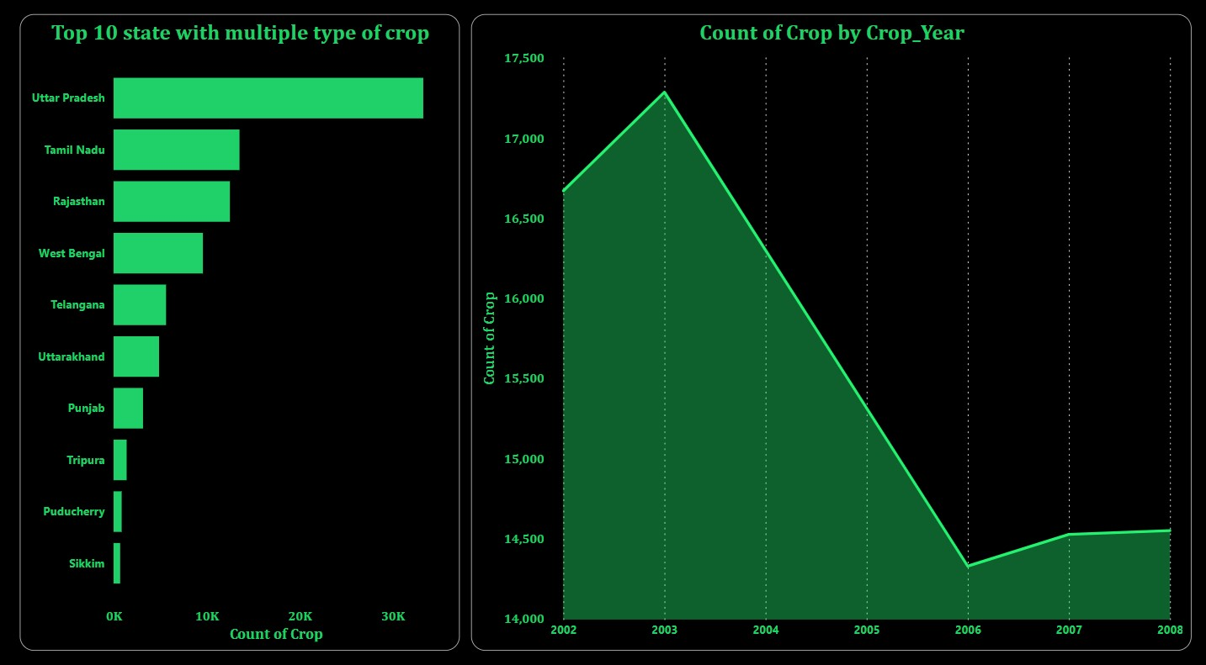

### HELPFUL INSIGHTS

1. Urad and wheat it is the crop that is the highest proudction ever.
2. 2002 to 2004 in between the maximum crop production occured.
3. Rabi and kharif in this season the maximum crop production produced.
4. Zunheboto and yatmal in this district there is maximum crop production produced.
5. Zunheboto in 2002 it is the highest year and district in that time sunflower and soyabean mostly produced.
6. Uttar Pradesh, Tamil Nadu and Rajasthan in this state there is a multiple type of crop produced.
7. 2003 to 2006 in this year the crop production is rapidly decreases.

# THANK YOU